LAB 2

TITLE: Creating table in MySQL database and performing the given queries.

OBJECTIVE: Create a table as the following schema and run the queries as given below.
student(stud_id, full_name, address, contact, age, gender, major_subject)
Queries:
- Select all records.
- Select records of all the males.
- Select name and address of all the female whose age is between 15 and 25.
- Display the stud_id and name of all the students in alphabetical order.
- Display the records of students sorted by age in ascending order.
- Display the total number of students.
- Display the number of male and female students.
- Display the average age of all the male and female students.
- Display the distinct major subjects.
- Display the number of major subjects taken by students.
- Display the name of youngest student.
- Name of all the students whose name starts from ‘s’ and are above 19 years.

THEORY:
MySQL: MySQL is an open-source relational database management system (RDBMS). It is widely used for storing, managing, and retrieving data in a structured format, typically in tables composed of rows and columns.
SQL: SQL, which stands for Structured Query Language, is a standardized programming language designed for managing and manipulating data stored in relational databases. It serves as the primary means of communication with these databases, allowing users to perform various operations on the data. Languages of SQL are:

- Data Definition Language (DDL): DDL commands are used to define and manage the structure of database objects.
- CREATE: Used to create database objects like tables, views, or indexes.
- ALTER: Used to modify the structure of existing database objects.
- DROP: Used to delete database objects.
- TRUNCATE: Used to remove all records from a table while retaining its structure.

- Data Manipulation Language (DML): DML commands are used to manage the data within database objects.
- INSERT: Used to add new records into a table.
- UPDATE: Used to modify existing records in a table.
- DELETE: Used to remove records from a table.

- Data Query Language (DQL): DQL commands are primarily used for retrieving data from the database.
- SELECT: Used to query and retrieve data from one or more tables.

- Data Control Language (DCL): DCL commands are used to control access and permissions within the database.
- GRANT: Used to give users or roles specific privileges.
- REVOKE: Used to remove previously granted privileges.

- Transaction Control Language (TCL): TCL commands are used to manage transactions, ensuring data consistency and integrity.
- COMMIT: Used to save all changes made during a transaction.
- ROLLBACK: Used to undo changes made during a transaction.
- SAVEPOINT: Used to set a point within a transaction to which you can later roll back.

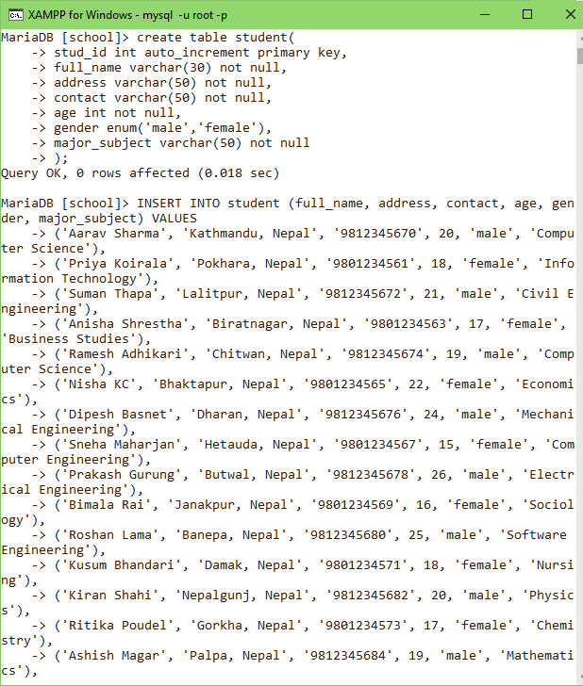
Creating Student Table

OUTPUTS:
- Select all records
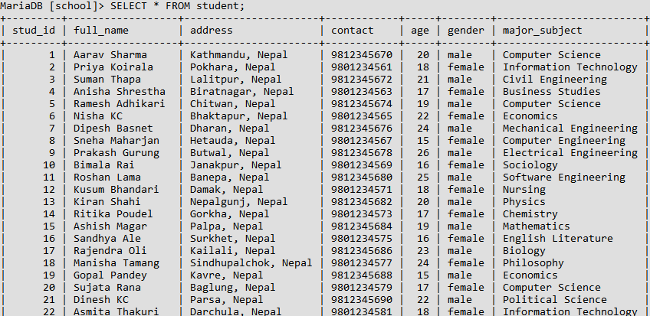

- Select records of all the males
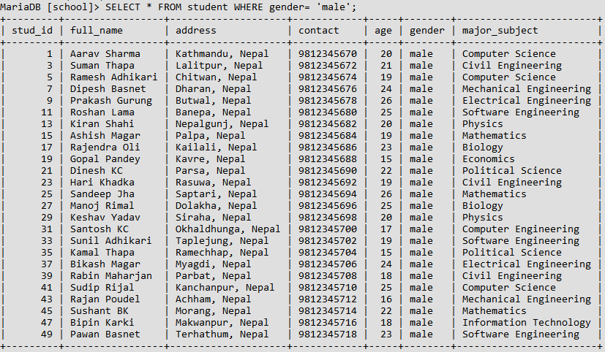

- Select name and address of all the female whose age is between 15 and 25
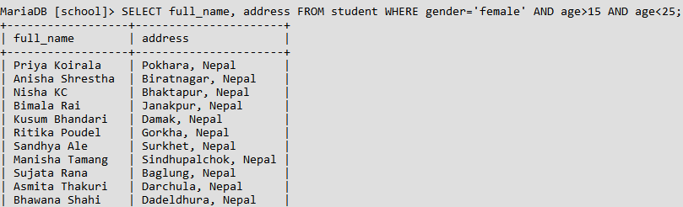

QUERIES
- Select all records
- SELECT * FROM student;

- Select records of all the males.
- SELECT * FROM student WHERE gender= 'male';

- Select name and address of all the female whose age is between 15 and 25.
- SELECT full_name, address FROM student WHERE gender='female' AND age>15 AND age<25;

- Display the stud_id and name of all the students in alphabetical order.
- SELECT stud_id, full_name FROM student ORDER BY full_name ASC;

- Display the records of students sorted by age in ascending order.
- SELECT * FROM student ORDER BY age ASC;

- Display the total number of students.
- SELECT COUNT(*) AS tot_student FROM student;

- Display the number of male and female students.
- SELECT gender, COUNT(*) AS tot_student FROM student GROUP BY gender;

- Display the average age of all the male and female students.
- SELECT gender, AVG(age) AS average_age FROM student GROUP BY gender;

- Display the distinct major subjects.
- SELECT DISTINCT major_subject FROM student;

- Display the number of major subjects taken by students.
- SELECT COUNT(DISTINCT major_subject) AS total_major_subjects FROM student;

- Display the name of youngest student.
- SELECT full_name, age FROM student ORDER BY age ASC LIMIT 1;

- Name of all the students whose name starts from ‘s’ and are above 19 years.
- SELECT full_name, age FROM student WHERE full_name LIKE 's%' AND age > 19;

OUTPUTS:
- Display the stud_id and name of all the students in alphabetical order
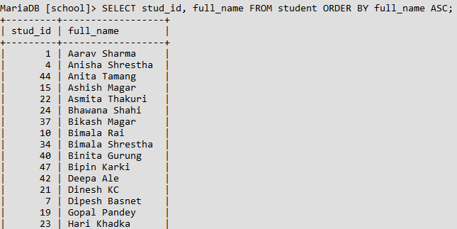

- Display the records of students sorted by age in ascending order.
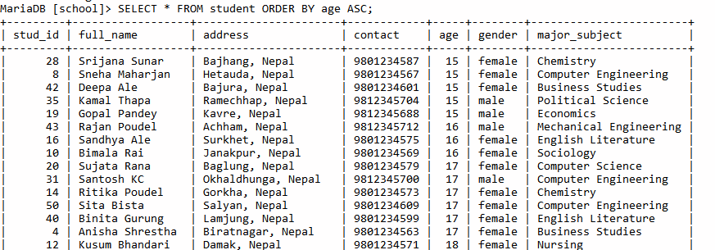

- Display the total number of students.
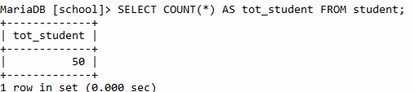

- Display the number of male and female students.
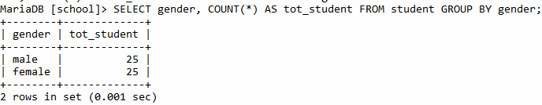

- Display the average age of all the male and female students.
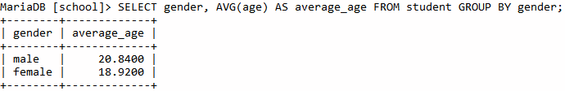

- Display the distinct major subjects.
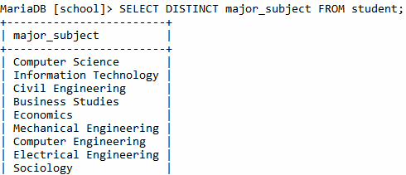

- Display the number of major subjects taken by students.
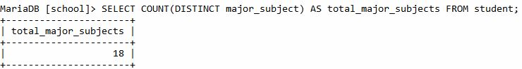

- Display the name of youngest student.
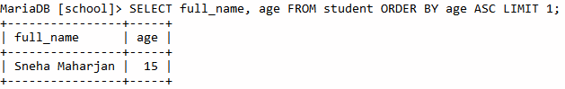

- Name of all the students whose name starts from ‘s’ and are above 19 years.
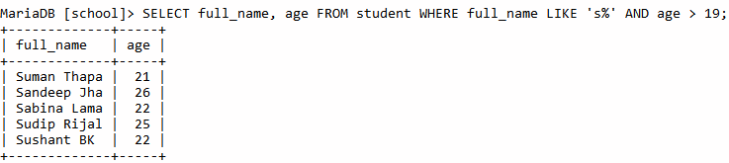

CONCLUSION:
The lab work gives the hand on experience in SQL commands and can successfully display the tables in terminal. The lab work is done for different SELECT commands to display tables and the valuable data from the student table.

